Graph Coloring Problem

Abstract
The paper, titled "Solving Graph Coloring Problems Using Cultural Algorithms" (2011) by Reza Abbasian, Malek Mouhoub, and Amin Jula, addresses the combinatorial optimization challenge of the Graph Coloring Problem (GCP). GCP, which requires finding the minimum number of colors (G) needed to color a graph's vertices such that no adjacent vertices share the same color. The authors propose a novel hybrid approach that leverages the strength of both systematic heuristics and non-systematic evolutionary computation.

This documentation presents our implementation of various solutions and optimizations for the Graph Coloring Problem (GCP) using Cultural Algorithm (CA) and Backtracking. We describe the design and implementation of the algorithms, the conducted experiments, obtained results, and the corresponding analysis and discussion. Additionally, we provide an overview of the applied algorithms, detailing their main functionalities and explaining how each of them operates.

Keywords: Chromosome, Belief, Population, Backtracking

Introduction
The Graph Coloring Problem (GCP) involves finding the minimum number of colors for coloring the graph vertices such that adjacent vertices have distinct colors.

This project addresses the GCP using two distinct approaches: Cultural Algorithm (CA) and the Backtracking Algorithm, both implemented in Python with an interactive GUI. The goal is to demonstrate that a single problem can be solved using multiple algorithms, each producing different types of results. While the Backtracking approach guarantees a valid chromatic number, it does not always yield the minimal one. In contrast, the Cultural Algorithm consistently aims to find the minimum chromatic number by starting with an estimated value and progressively improving it through its belief space mechanism.

Cultural Algorithm

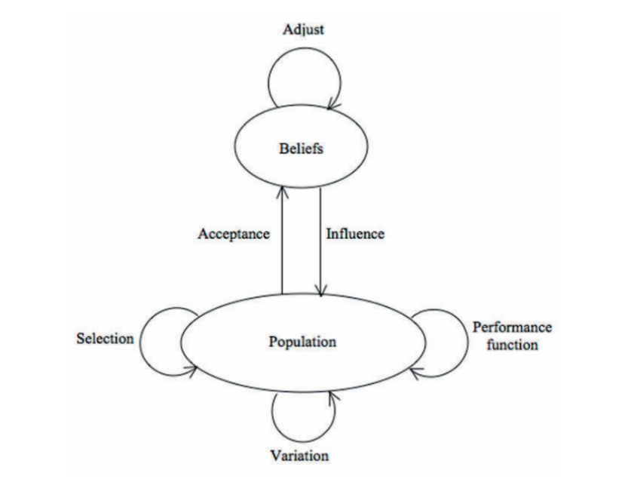
2.1 Basic Concepts of Cultural Algorithm
Figure 1 – Illustration of Cultural Space
Cultural algorithms were developed by Robert G. Reynolds as a complement to the metaphor adopted by evolutionary algorithms, which was mainly focused on genetic concepts and on the natural selection mechanism (Reynolds 1994). Cultural evolution can be seen as an inheritance process that occurs at two levels: micro-evolutionary level (Population Space) and macro-evolutionary level (Belief Space). At the first level, behavioral traits are passed from generation-to-generation by genetic operators. At the second level, individuals generate a map of experiences (mappa) used to influence the population space. Individuals (the best-performing ones) generate a local map of their experiences (e.g., their parameters and fitness). Experiences (chromatic number and fitness) are passed to the macro-evolutionary level (Belief space) where it is generalized and merged into the collective knowledge structure as a guide to the rest of the population space. The main goal of the algorithm is efficiency and effectiveness of the search process by biasing or guiding the behavior of the stochastic search. In this report we will show you how we implemented the algorithm by proposing two solution steps : Estimation Phase (EP) and Improvement Phase (IP).

Generate the initial population
Initialize the belief space
Evaluate population
repeat
update belief space
apply variation to population space
evaluate each child
perform selection
Terminate when termination condition is true
Pseudo-code for the algorithm

2.2 Two-Phase Algorithm
The core contribution of the study is a two-phase method that significantly improves search efficiency by providing a highly focused initial solution space for the evolutionary component.

2.2.1 Estimation Phase
The main goal of the EP is to provide a better upper bound to the Improvement phase. There are two ways to implement the EP. The first one we implemented is the minimal one. It just gets the best individual in the population and passed it as initial input to the Improvement phase. The second one is to follow a quick greedy heuristic called: Sequential Graph Coloring Heuristic Algorithm (SGCHA). This approach enhances the initial upper bound , however , as of now it is not implemented.

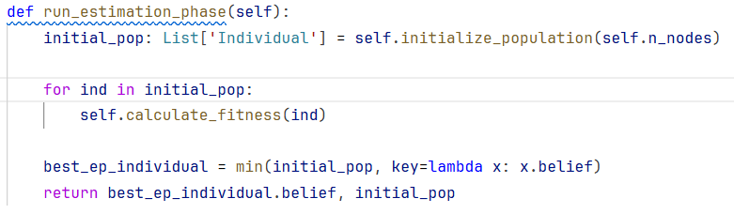
This is the code implementation for the EP in our Simulation:
The run_estimation_phase initializes the population
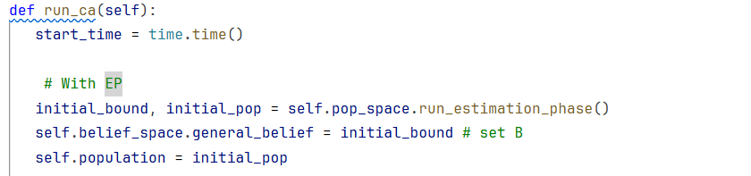
---------------------------------------------------------------------------

2.2.1 Improvement Phase
This phase employs the Cultural Algorithm (CA) to refine the solution provided by the EP. The EP’s estimate becomes the “General Belief” in the CA’s Belief Space, effectively restricting the mutation operation of each individual in the population.

Prior to the implementation of the algorithm, these terms must be described.

- Belief of Individual: The belief of an individual is it’s suggestion on the distinct number of colors that is minimum for coloring that graph.

- Belief of Group: The belief of a group is the number of colors that the group suggest as the minimum number of colors to solve the problem.

- General Belief: The general belief is the best solution found so far, this is the current minimum number of colors.

- Group: set of individuals that has the same belief.

Next, the components used in the algorithm are described in detail

1. Individual Representation
Each individual in the population is represented with an integer array, it’s length is the number of vertices. The value of each column is the number of colors which is not more than the general belief. Figure 2 illustrates an example of a chromosome.
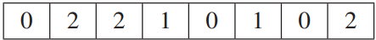
Figure 2 – Illustration of a chromosome
Code Representation : -
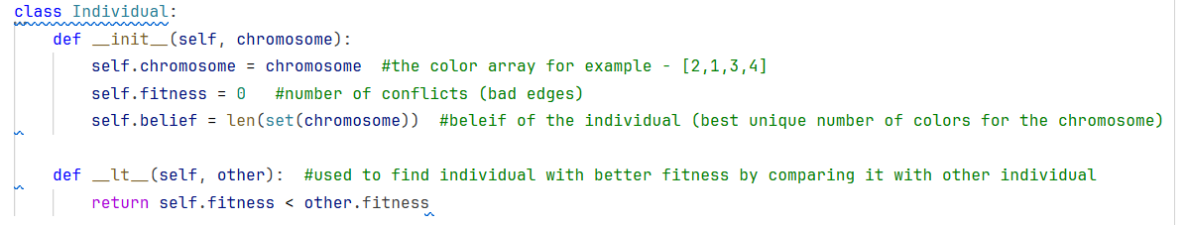
2. Fitness Function
The fitness function evaluates the number of conflicts that might exist among adjacent vertices which have the same color. In order to compute this value we simply find adjacent vertices from the graph adjacency matrix and check their color number in the integer array of the individual. Therefore, the total number of color conflicts is the result of the fitness function. When the result is equal to zero, a solution is found.
The fitness of a solution is defined as follows:

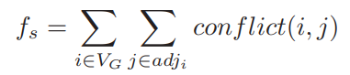

The conflict function is defined as follows:

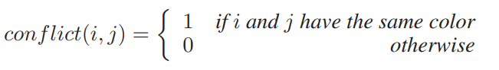

3. Reproduction and Crossover
Reproduction takes place amongst a number of fittest individuals of each group and amongst fittest individuals of different groups. The chosen individuals are then passed to crossover as parents of new individuals. To produce each new child, the crossover operator randomly chooses a pivot. It then finds the vertex colors of the first parent’s vertices which have a vertex number less than or equal to the pivot and concatenates them with the vertex colors of the second parent’s vertices which have a vertex number greater than or equal to the pivot. Figure 3 shows an example of the crossover with a pivot equal to 2 on two individuals of a five-vertex graph coloring problem.
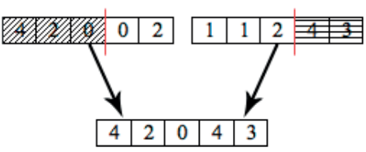
Figure 3 - Example of crossover

The reproduction and crossover operations are performed under the influence of the belief space. To proof this, we already rely on the fact that each individual in the population has number of colors less than or equal the general belief.

4. Mutation
As we discussed , in a cultural algorithm , the mutation is influenced by the belief space. Here the influence means operating in the range of colors which are less than or equal to the general belief. We proposed two mutation functions same as the one stated in the research paper
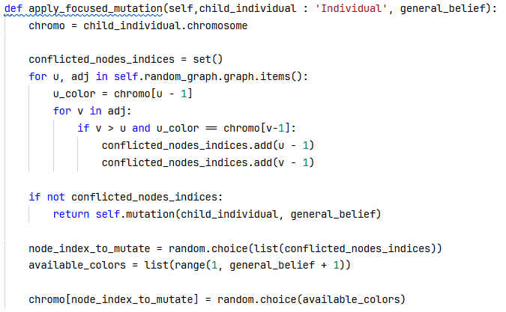
- Mutation to minimize the number of conflicts, we renamed it to Focused Mutation
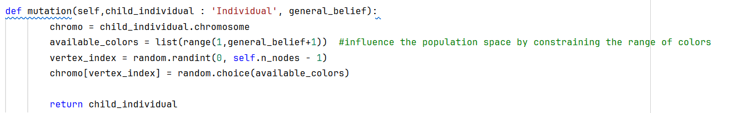
- Random Mutation

5. Self Adaptiveness
The proposed algorithms keeps track of the ratio of improvement of each group (r_{g}) and the best individuals in available groups. Whenever the algorithm finds out that there is no improvement, it adds new K_{g} randomly generated individual to each group with an increased mutation chance until there is improvement; once there is improvement, it removes the additional individuals from the population and resets the mutation chance back to it’s initial value

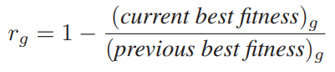
The ratio of improvement is a value between 0 and 1, we can use this to calculate the relevant number of individuals to inject:
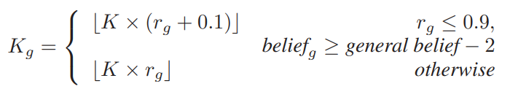

6. Stopping Criteria
The algorithm is allowed to enter the Self Adaptive phase S times, if there is no improvement for S times, the algorithm will terminate, otherwise if there is improvement, continue until fitness of zero is reached and return the final solution.

2.4 Experimental Results and Comparative Analysis

EP Impact

Metric | EP Enabled (Run A) | EP Disabled (Run B) | Analysis
Final Status | Success | Success | Both runs found a valid, conflict-free coloring (Fitness 0).
Population Size | 440 | 440 | Constant input parameter.
Mutation Rate | 0.1 | 0.1 | Constant input parameter.
Max Stagnation | 50 | 50 | Constant input parameter.
Colors Used (Solution Quality) | 77 | 79 | EP Advantage: The EP successfully established a superior initial color constraint, leading to a 2-color improvement in the final solution.
Total Generations (Convergence Speed) | 115 | 98 | EP Penalty: The tighter constraint (B=77) made the problem harder to solve, increasing the number of generations required to resolve conflicts.
Execution Time (Computational Cost) | 55.255s | 39.064s | The increased generation count directly translated to a higher execution time when EP was enabled.
Parent Selection | Random (Exploration) | Random (Exploration) | Constant across both runs.
Mutation Type | Stochastic (Exploration) | Stochastic (Exploration) | Constant across both runs.
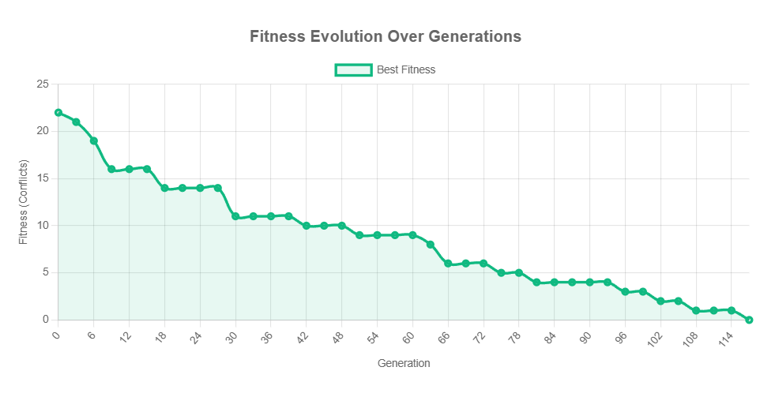
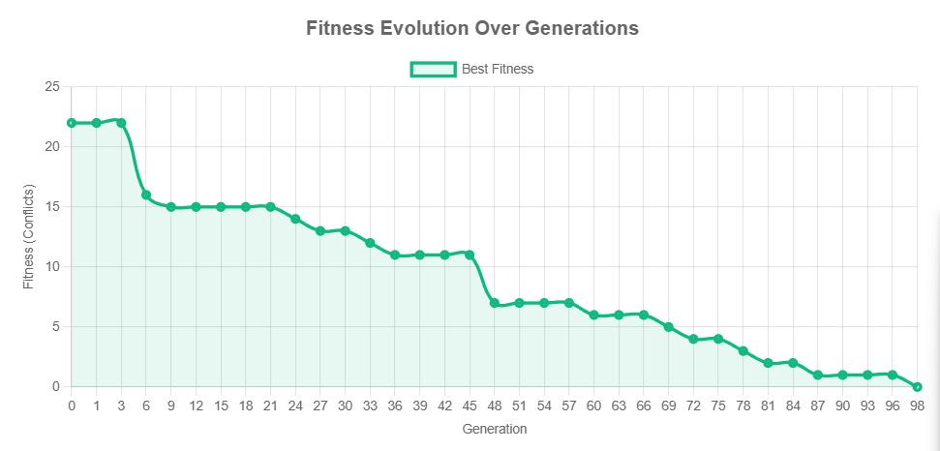
Figure 4 - EP Enabled
Figure 5 - EP Disabled

Selection Strategy Comparison: Random vs. Tournament

Metric | Run 1 (Random Selection) | Run 2 (Tournament Selection) | Analysis
Estimation Phase (EP) | Enabled | Enabled | Crucial Context: The EP established an initial high-quality belief in both runs.
Parent Selection | Random (High Exploration) | Tournament (High Exploitation) | Core Difference: Random selection maintains maximum diversity by giving every individual an equal chance to reproduce, regardless of fitness. Tournament selection introduces strong pressure, favoring fitter individuals.
Colors Used (Solution Quality) | 77 | 81 | Quality Advantage (Random): Random Selection achieved a better solution, utilizing only 77 colors. This outcome is likely due to the highly exploratory nature of the random selection, which prevented the algorithm from quickly converging to a local optimum dictated by the EP's initial belief. By maintaining a wider array of diverse solutions for longer, the algorithm had a greater chance to overcome initial constraints and explore the boundary of the feasible space, ultimately finding a tighter constraint (77) than the Tournament selection.
Total Generations (Convergence Speed) | 115 | 60 | Speed Advantage (Tournament): Tournament selection achieved convergence almost twice as fast. The increased selective pressure aggressively eliminated lower-fitness individuals, rapidly focusing the population's trajectory towards a conflict-free solution. This efficiency came at the cost of solution quality.
Execution Time | 54.471s | ~22s | Computational Cost: The lower generation count of the Tournament run (60 vs 115) directly translates to a significant reduction in execution time. While the explicit time for Run 2 is not provided, the reduction in generations indicates a substantial computational saving of approximately 50%, highlighting the practical efficiency gain of a focused exploitation strategy.
Max Stagnation | 50 | 50 | The algorithm in both cases successfully overcame the stagnation threshold and halted due to achieving the optimal fitness (0), rather than hitting the stagnation limit.
Best Fitness | 0 | 0 | Both selection methods successfully resolved all conflicts, but with different solution quality outcomes (77 colors vs 81 colors).
Population Size, Mutation Rate | 440, 0.1 | 440, 0.1 | These constants isolate the effect of the selection strategy, ensuring the differences observed are solely attributable to how parents are chosen.

Mutation Strategy : Stochastic vs Focused

Metric | Run 1: Normal (Stochastic/Random) | Run 2: Focused (Targeted Repair) | Analysis
Mutation Type | General Color Assignment | Conflict Repair Only
Final Quality (Colors) | 116 (Worse) | 110 (Best) | Focused is significantly superior for quality. Targeted repair is more effective than random perturbation.
Total Generations | 69 (Slower) | 33 (Faster) | Focused converges much faster. The direct repair mechanism efficiently reduces fitness, leading to quicker stabilization.
Execution Time | 50.460s (Slower) | 14.859s (Much Faster) | Focused is drastically faster. It reduced execution time by over 70%, driven by the massive reduction in required generations.
Algorithm's Strength | Exploration / Diversity | Exploitation / Refinement

Analysis of the crossover strategy
The genetic operator used to combine parental chromosomes and create new candidate solutions in the current implementation is the One-Point Crossover. This strategy is implemented in the crossover method within the PopulationSpace class.

Detailed description of the crossover strategy
One-Point Crossover is the simplest and most traditional form of recombination used in Genetic Algorithms.

Mechanism:
  - Selection : Select p1, p2 (Tournament Selection in our case)
  - Crossover point : A single random point is chosen along the length of the chromosome
  - Recombination : The child chromosome is constructed by :
    - Taking the first segment of p1 from the start up to the crossover point
    - Taking the second segment of p2 from the (Crossover Point) + 1 to the end.

Analysis of the elitism
Applying elitism is redundant because already the EP provides an early optimum solution with fitness = 0, so we removed it from our implementation

Analysis of Population size

Metric | Run 1: Large Population (500) | Run 2: Small Population (40)
Population Size | 500 (High Diversity/Wider Sampling) | 40 (Low Diversity/Focused Search)
Final Quality (Colors) | 113 | 111 (Better)
Total Generations | 48 (Faster) | 130 (Slower)
Execution Time | 35.719s | 19.340s (Faster)

As seen in the comparison table the higher the population the lower the quality of the chromatic number, because looking for any solution that has fitness = 0 is easier, on the other hand when the population is small the quality of the chromatic number is better because it makes it easier for the belief space to influence the population.
The number of generations to find the solution in the Large population is only 48 , much faster than the low population.

Conclusion
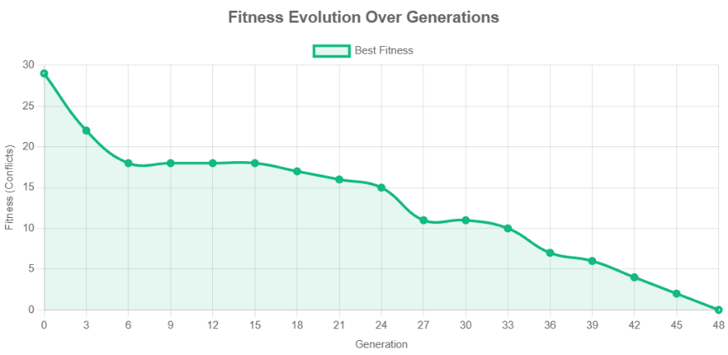
Yielding a small population size produces better results in terms of the chromatic number.

2.5 Flowchart

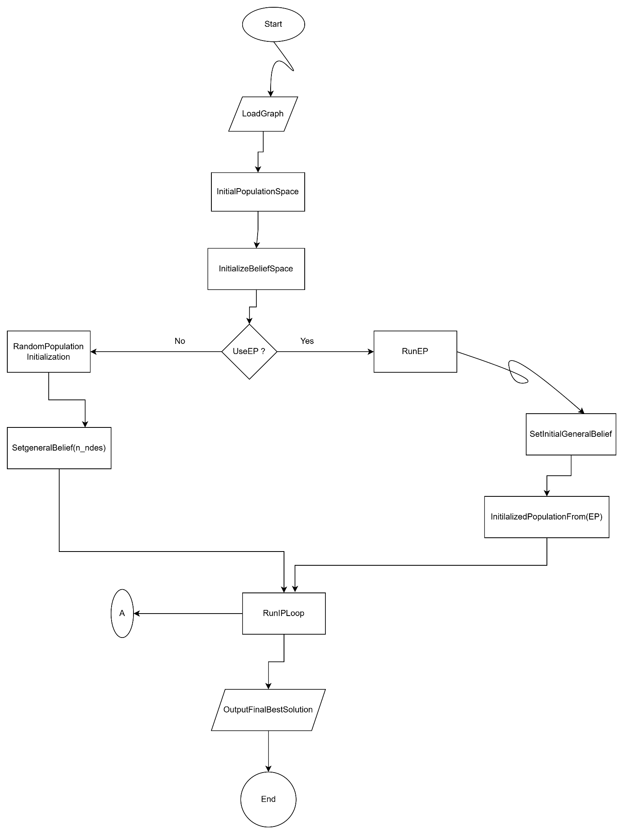

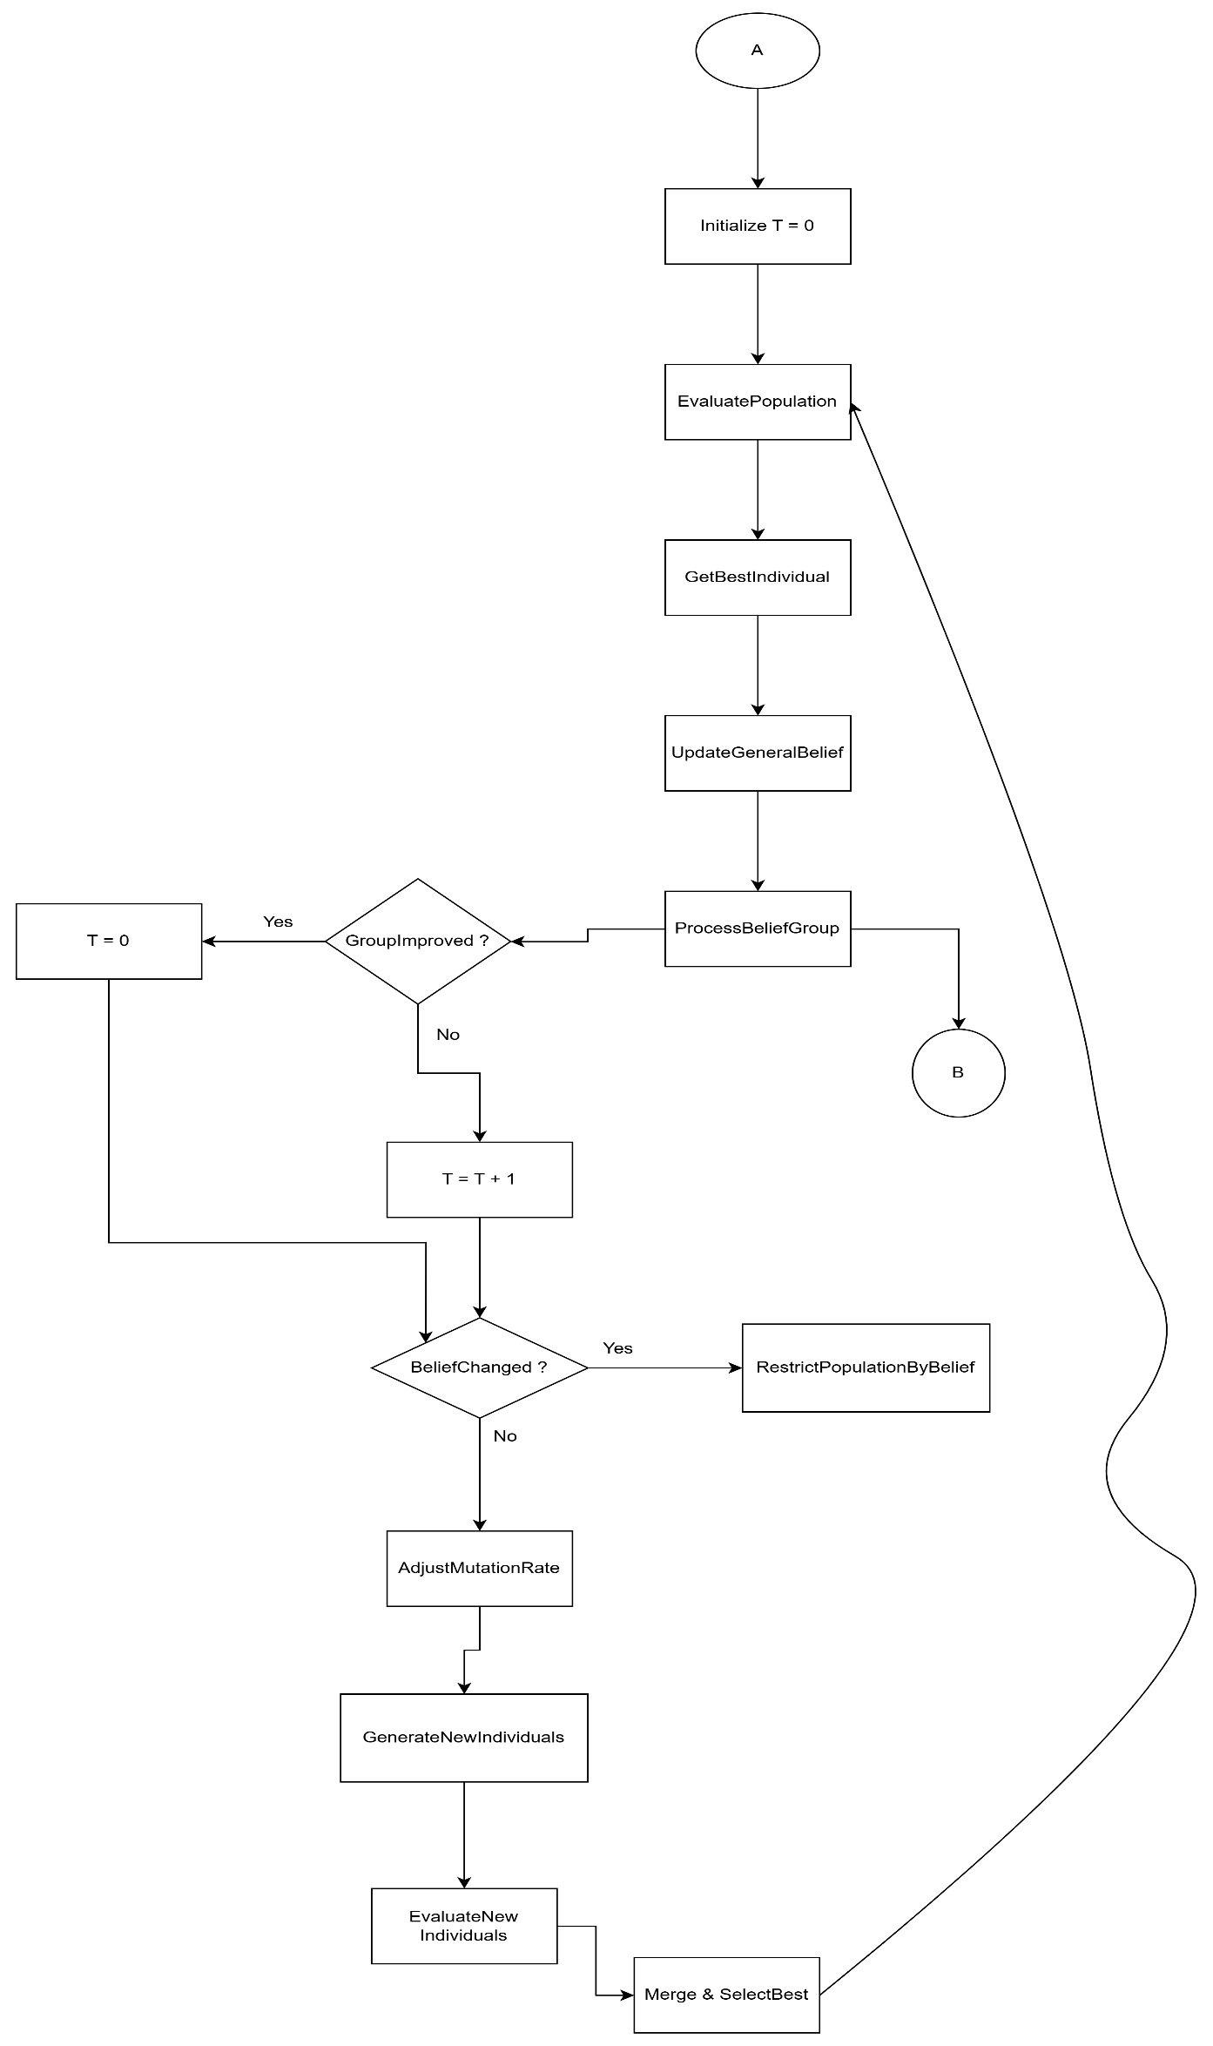

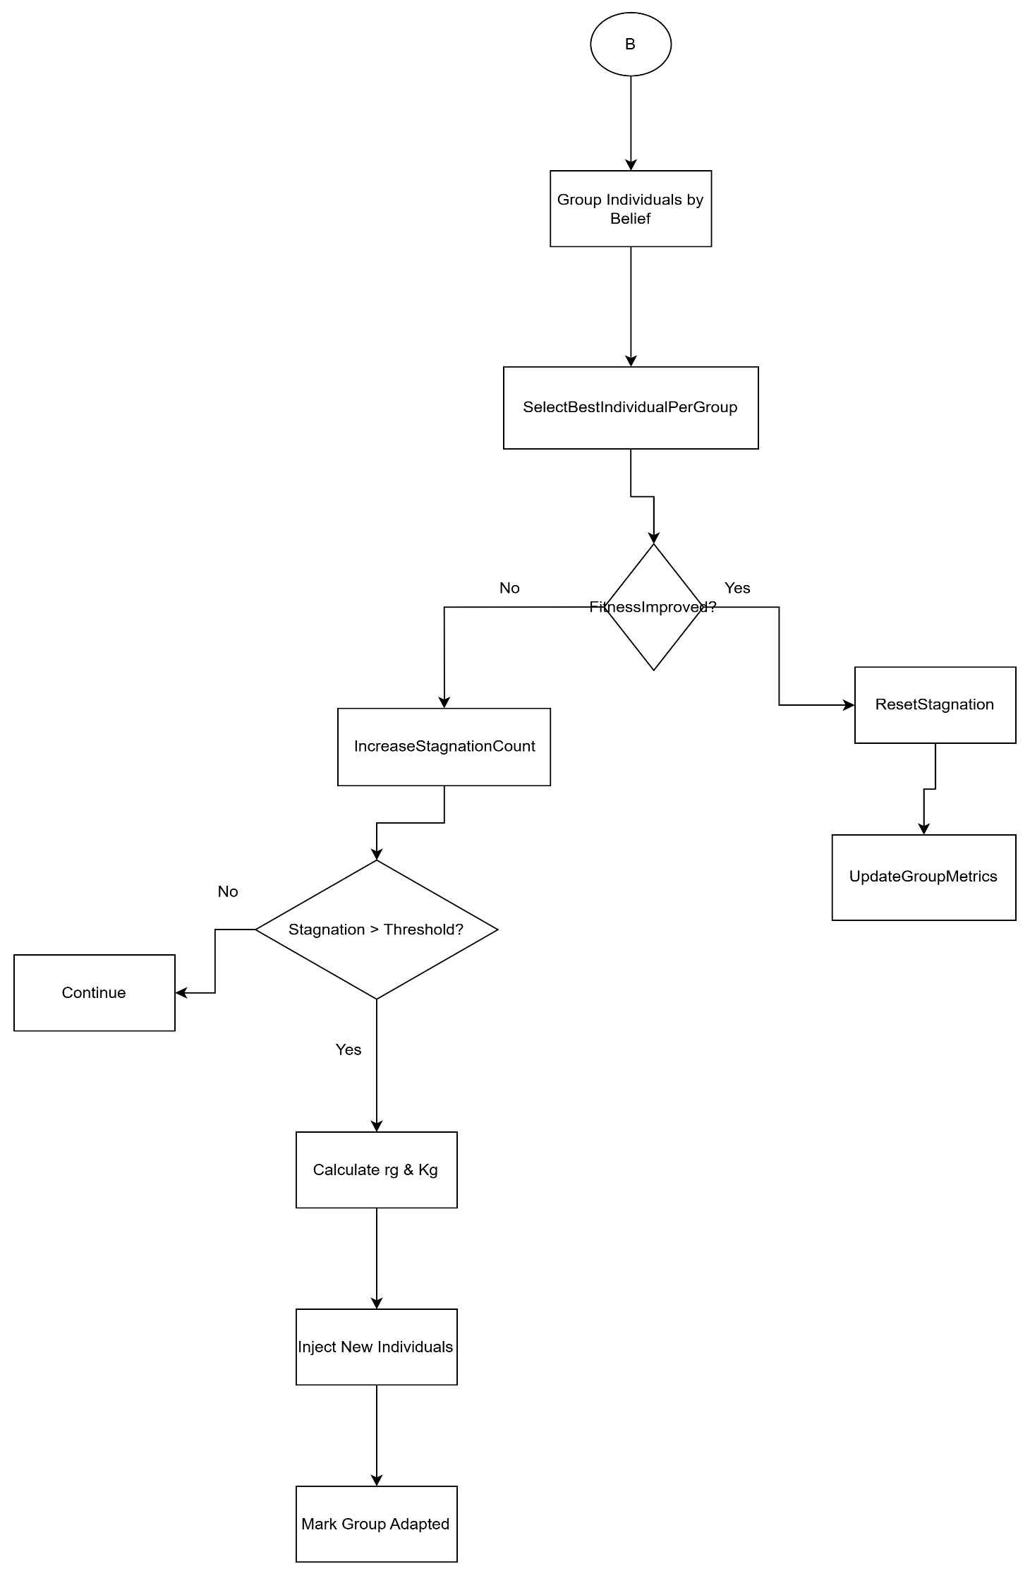

2.6 Block Diagram

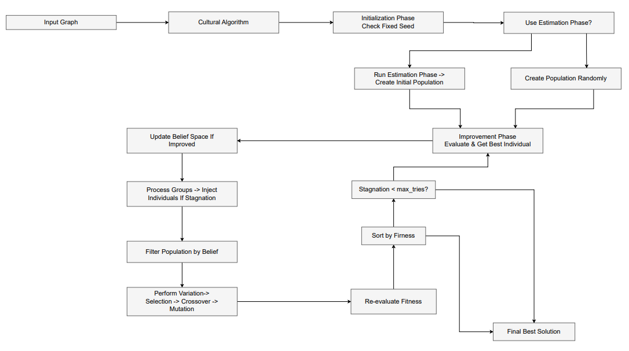

Backtracking Algorithm

3.1 Basic Concepts of Backtracking
Backtracking is a systematic algorithmic technique for solving constraint satisfaction problems (CSPs) like the Graph Coloring Problem. Unlike the stochastic nature of the Cultural Algorithm, Backtracking builds candidates for the solution incrementally. It explores the state space by assigning a color to a vertex and checking its validity against strict constraints (no two adjacent vertices share the same color). If the current candidate cannot be extended to a valid solution (i.e., a conflict arises), the algorithm abandons it ("backtracks") and returns to the previous step to try a different path. This guarantees completeness: if a solution exists within the given constraints, the algorithm will find it.

3.2 State Space Search & Implementation Logic

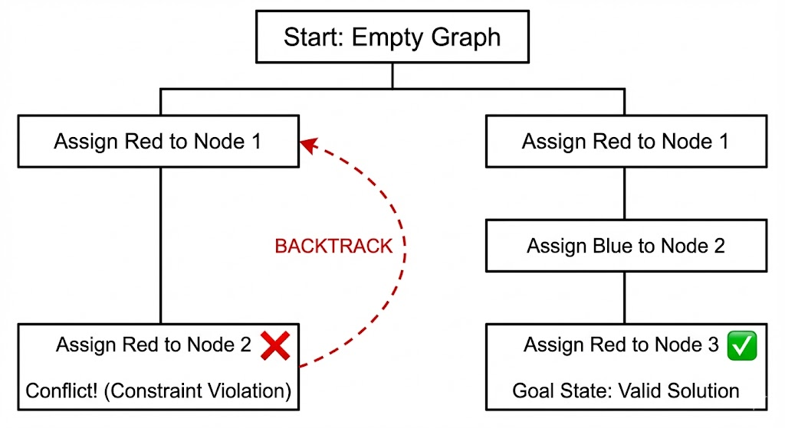
Figure 4 – Illustration of Backtracking Space

The visual representation above (Figure 4) illustrates the step-by-step decision process executed by our algorithm. This visual flow directly mirrors the logic implemented in the solve_standard function shown in the code snippet. The process involves four key stages:
  - Initialization (Root Node): The algorithm starts with an empty solution state. This corresponds to the initial call solve_Standard(0) in the code, where the recursion begins at the first node.
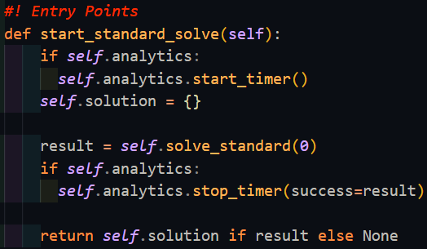
  - Forward Exploration (Actions): The downward paths in the diagram represent the Recursive Calls inside the loop for color in self.colors. For instance, the left branch shows an attempt to assign Red to Node 1, followed by an attempt to assign Red to Node 2.
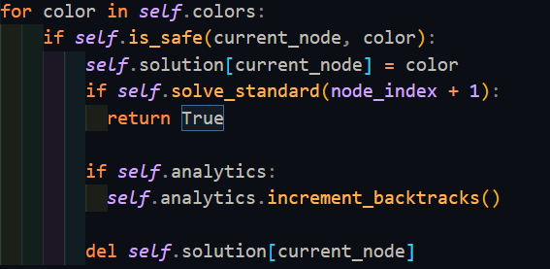

  - Conflict Detection (The 'X' Mark): When the algorithm attempts to assign Red to Node 2 (while Node 1 is also Red), a constraint is violated.
In the Diagram: This is marked with a bold X.
In the Implementation: This is where the function self.is_safe(current_node, color) returns False. The algorithm detects that the neighbor (Node 1) holds the same color, identifying this path as invalid.
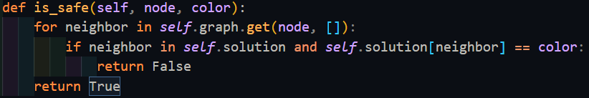

  - Backtracking & Pruning (Dashed Arrow): Instead of continuing deeper into an invalid path, the algorithm "backtracks".
In the Diagram: The curved dashed arrow shows the return to the previous decision point.
In the Implementation: This corresponds to the line :
del self.solution[current_node] This action effectively prunes the invalid branch, discarding the failed state to explore the next available color (e.g., Blue) as shown in the successful right branch.
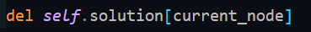

  - Goal State (Valid Solution): The path ending with a green checkmark represents a sequence of assignments where is_safe() returned True for every node. This corresponds to the Base Case in our code: if node_index == len(self.nodes): return True.
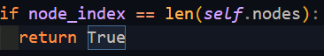

3.3 Optimization Strategy
While the standard backtracking algorithm guarantees finding a valid solution, it suffers from exponential time complexity O(m^n) and acts as a "Greedy" approach (First-Fit), which does not guarantee the minimal chromatic number. To address these limitations and satisfy the project's requirement of minimizing the number of colors, we implemented two key optimization techniques in our "Scientific Mode":
1. Domain Reduction (Forward Checking): Before attempting to assign a color to a current vertex, the algorithm inspects its neighbors. Colors that are already assigned to adjacent vertices are removed from the domain of valid colors for the current vertex.
- Benefit: This preemptively identifies "dead ends" before entering the recursion, significantly reducing the number of invalid branches explored (Pruning).
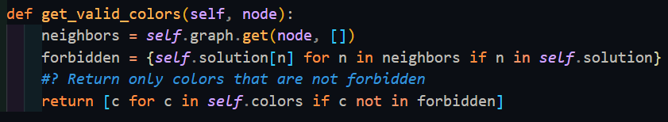
2. Iterative Deepening Search (IDS): To scientifically guarantee finding the Chromatic Number (Minimum colors needed), the algorithm does not just use all available colors. Instead, it attempts to solve the graph incrementally:
- Try solving with k=1 color → Fail.
- Try solving with k=2 colors → Fail.
- Try solving with k=3 colors → Success.
- Benefit: The first successful k is proven to be the minimal number, ensuring optimality.
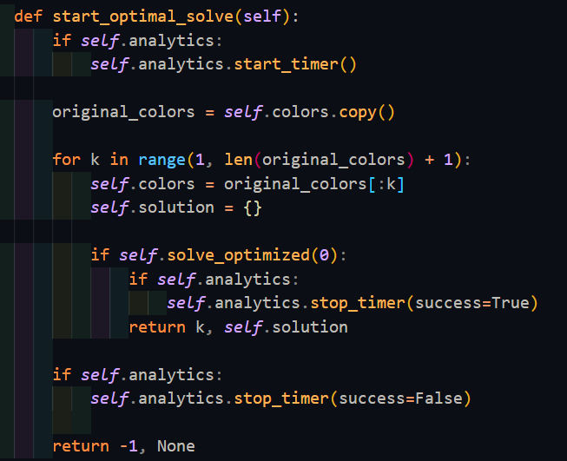 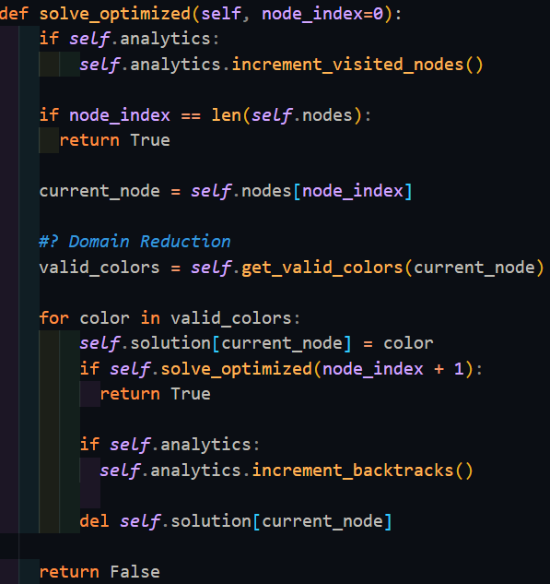

3.4 Experimental Results & Comparative Analysis
To evaluate the efficiency and accuracy of our implementation, we conducted a controlled experiment using a complex, clustered graph generated by our tool.
A. Experiment Setup (Test Case):
- Graph Topology: Planetary Layout (Disconnected clusters to test connectivity handling).
- Complexity: N=20 Nodes, E=45 Edges.
- Objective: Compare the behavior of the "Standard Mode" (given excess resources) vs. the "Scientific Mode" (finding the minimal optimum).
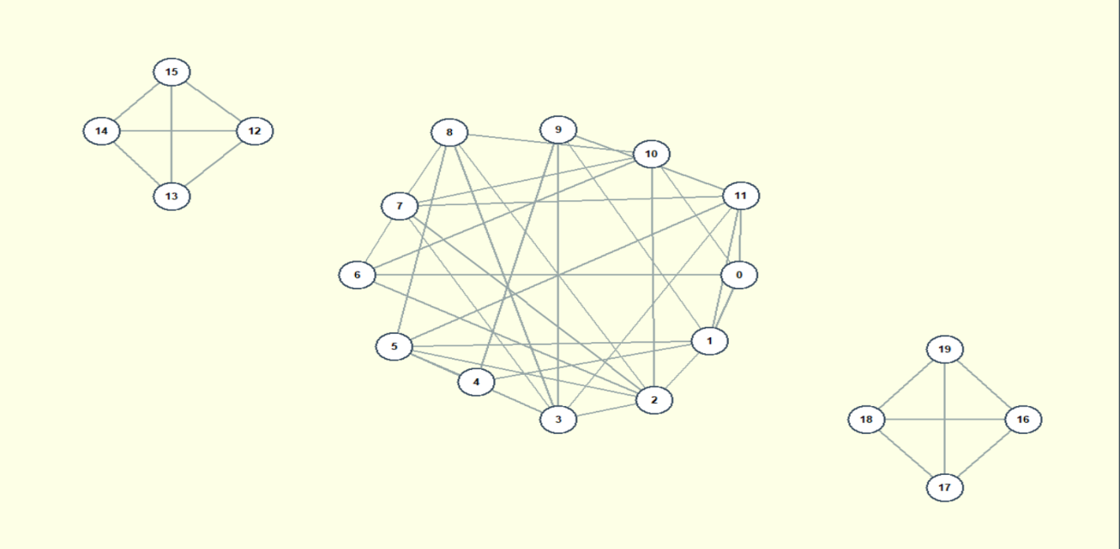

B. Scenario 1: Standard Mode (Greedy Approach) We first executed the Standard Backtracking algorithm, providing it with a loose constraint of 15 available colors.
- Observation: The algorithm acted in a "Greedy" (First-Fit) manner. Since it had an abundance of colors (15), it simply assigned the first available valid color to each node without needing to backtrack heavily to save colors.
- Result: While it found a valid solution very quickly, it did not strictly enforce the minimal number of colors, as its priority was finding any valid solution within the 15-color limit.
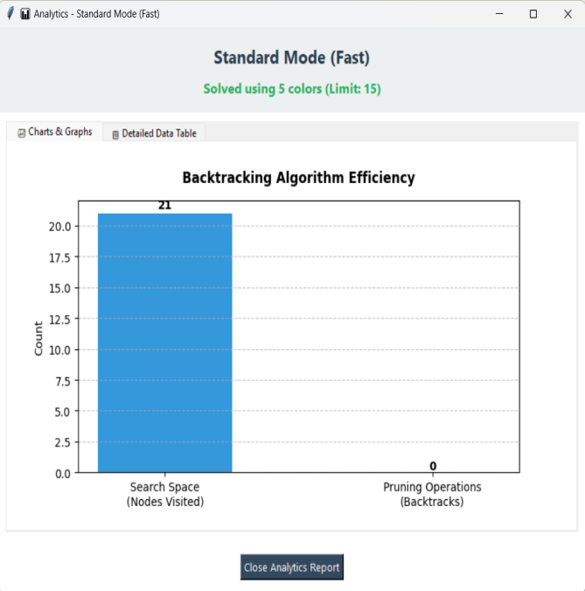 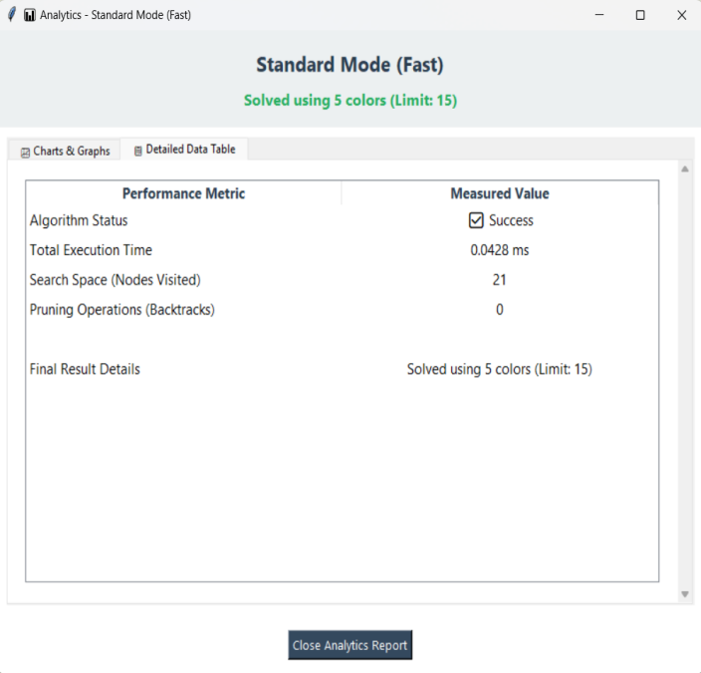

C. Scenario 2: Scientific Mode (Optimized & Minimal) Next, we executed the Scientific Mode to find the true Chromatic Number.
- Observation: The algorithm utilized Iterative Deepening. It attempted to solve with k=1, k=2, and k=3 (failing each time), before successfully solving with k=4.
- Analytics Insight: As shown in the dashboard below, the algorithm visited 178 nodes and performed 154 pruning operations (backtracks). This high number of backtracks proves that the algorithm was rigorously exploring and discarding invalid paths to guarantee that no solution existed with fewer than 4 colors.
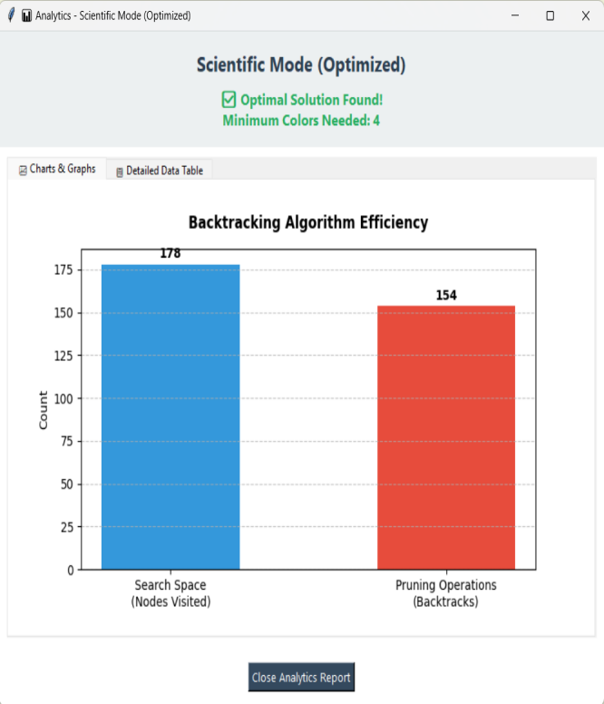 

Feature | Standard Mode | Scientific Mode
Strategy | First-Fit (Greedy) | Iterative Deepening + Domain Reduction
Input | User-defined Limit (15 Colors) | Auto-detected (Start from 1)
Goal | Find a Valid Solution | Find the Minimal Solution
Result | Valid Coloring | Optimal Coloring (4 Colors)

Conclusion: The experiment confirms that while Standard Backtracking is efficient for general constraint satisfaction, the Optimized Scientific Mode is essential for operations requiring resource minimization (Chromatic Number), as evidenced by the rigorous pruning process shown in the analytics.

3.5 Flowchart
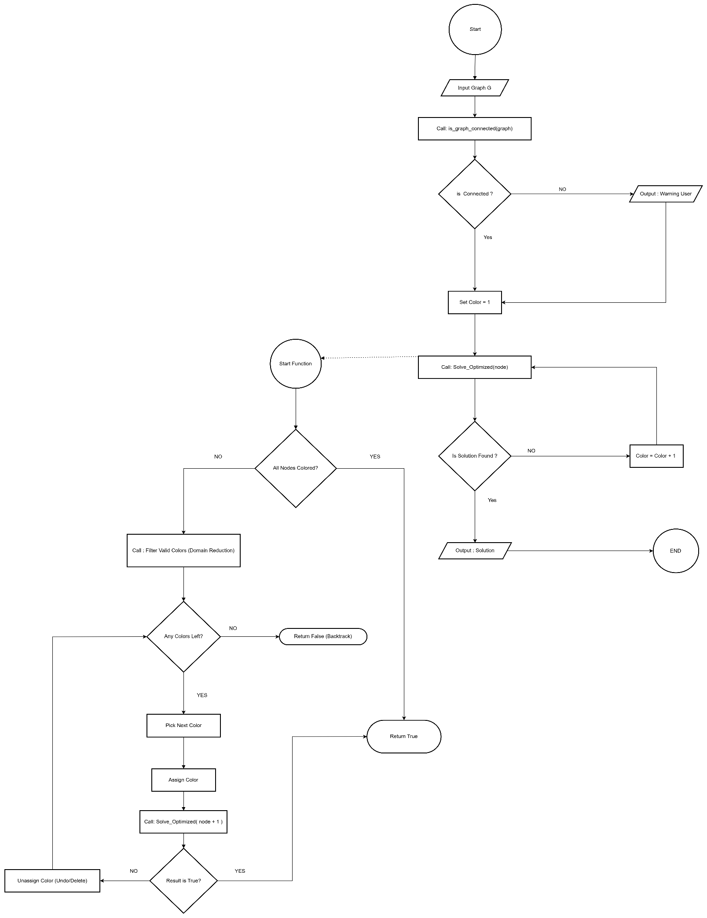

3.6 Block Diagram
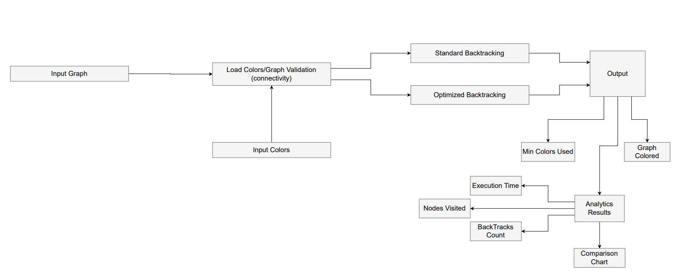

- System Usecase Diagram

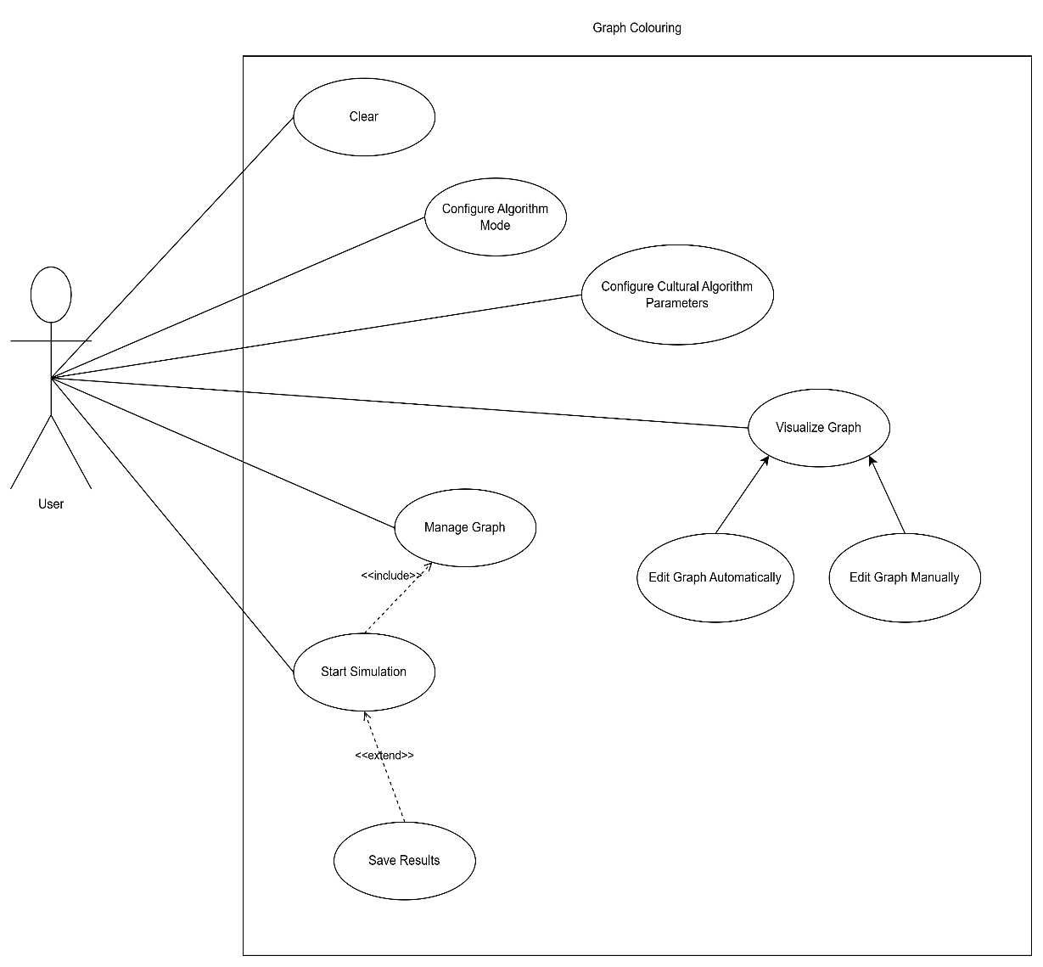

- Development Platform/s
Visual Studio
Draw.io
Microsoft Word
Github

- References

